Purpose: To provide vendors with additional information regarding the processing of shipments in the Vendor Shipment Module (VSM).

In May of 2015, DCMA St Louis came on board with VSM. When you log into the system, off to the right you will notice an agency column that will state if the order belongs to DLA or DCMA:

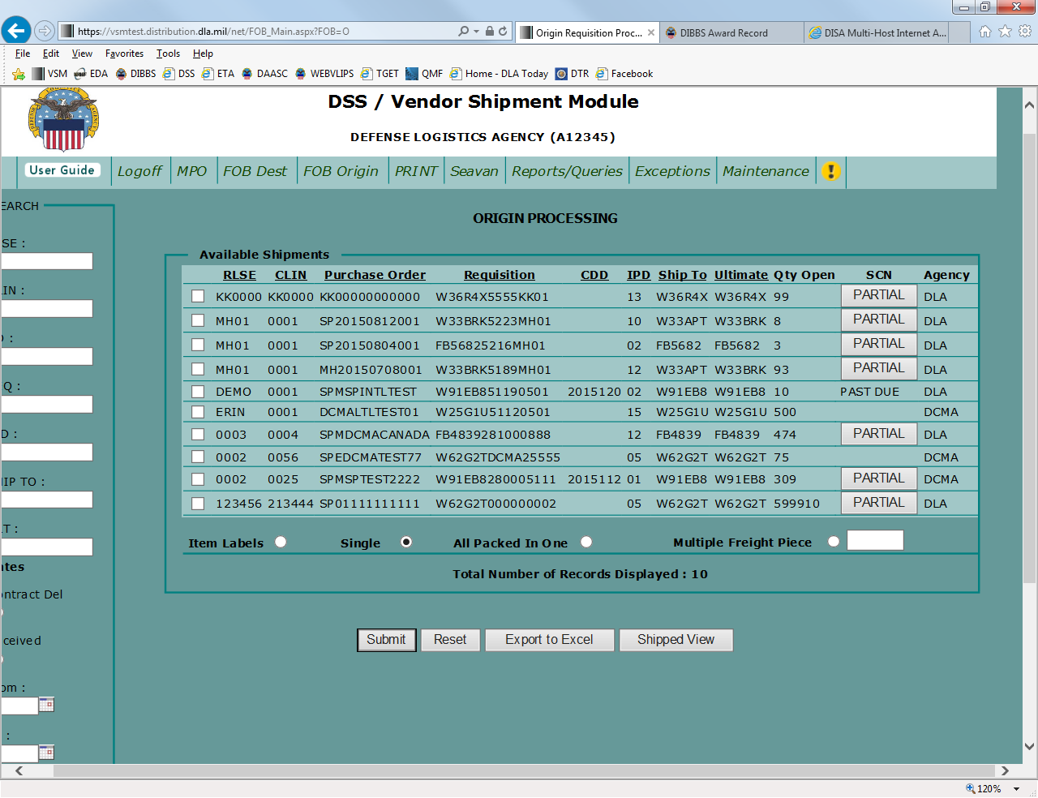

If you require any assistance with your contract, you will need to contact the agency that is listed to the right of the order. So if you process a DLA issued and administered contract, it will show DLA in the agency column and you should call or email DLA. If the agency column shows DCMA, you should contact DCMA. All of the contact information is listed on the main log on page of VSM (https://vsm.distribution.dla.mil):

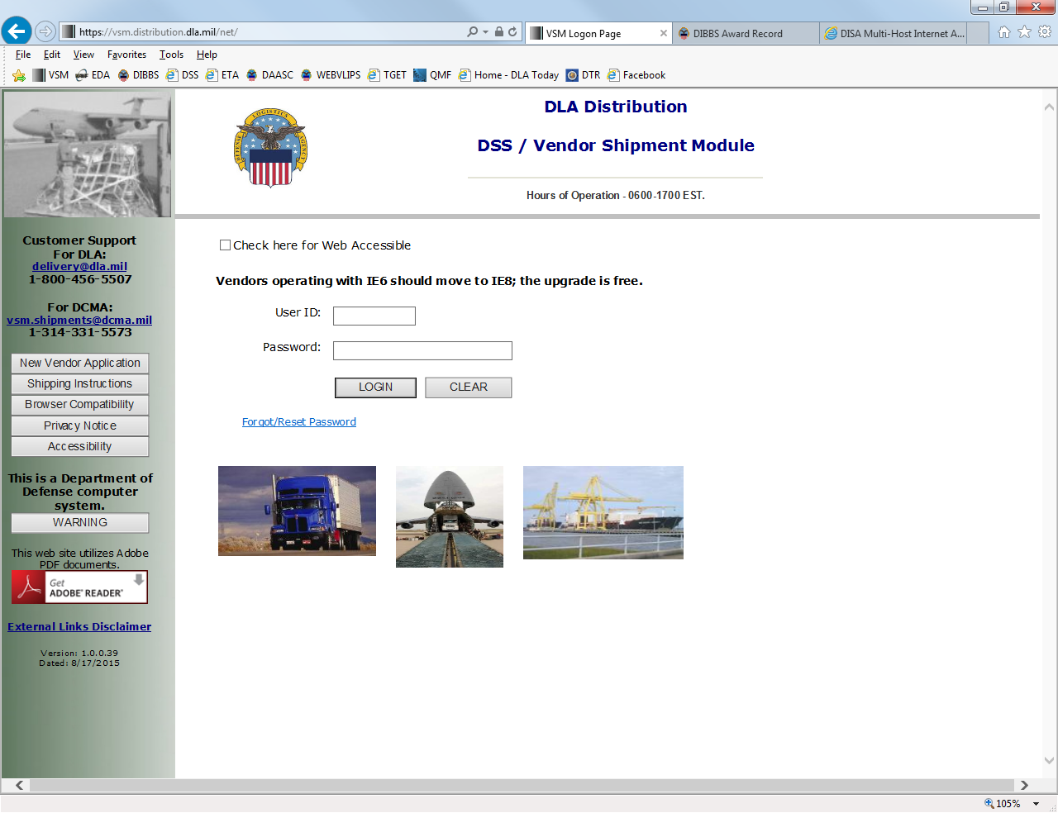

Customer Support
For DLA:
delivery@dla.mil
1-800-456-5507
For DCMA:
vsm.shipments@dcma.mil
1-314-331-5573

IF YOUR SHIPMENT REQUIRES DCMA INSPECTION DO NOT ENTER ANYTHING INTO VSM UNTIL AFTER THE INSPECTION HAS BEEN COMPLETED.

If you do not follow the above procedures, a carrier will arrive at your facility and you will not be able to release the shipment. Additional charges will be incurred.

If your shipment requires a DCMA inspection, you will need to schedule an appointment for that inspection in Wide Area Work Flow (WAWF). You will need to have the ultimate consignee in order to schedule your inspection. Your ultimate consignee is found in your contract as shown below. Once you complete the request in WAWF, you should receive an inspection appointment no later than two (2) days for a resident QAR and seven (7) days for a non-resident QAR. Once the inspection has occurred and the inspector has approved your shipment, you are ready to enter your shipment details in VSM.

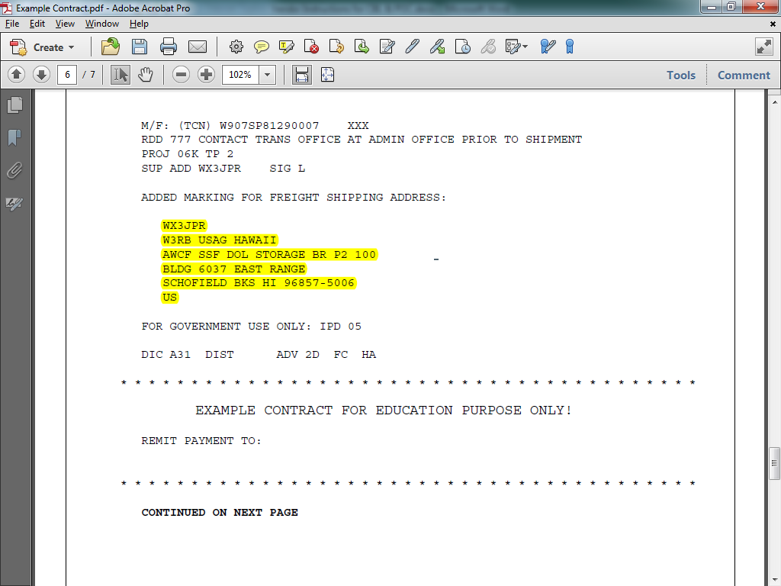

The Ultimate Consignee can be found in the Freight Shipping section of your contract.

The next few pages describe the shipping documents and the date you can expect the carrier at your facility AFTER processing in VSM.

- DO NOT CONTACT MENLO PERTAINING TO YOUR SHIPMENTS.

- Any questions relating to shipments are to be directed to the Defense Logistics Agency (DLA) Distribution transportation office at delivery@dla.mil or 800-456-5507.

- ALL shipments should be packed and ready for shipment at the time you process in the Vendor Shipment Module (VSM).

- Small Parcel Shipments are shipments that are less than 150 lbs., less than 12 cubic feet and are under a total girth of 130. Girth is calculated - Length and girth equals length plus twice the width and twice the height (L + W(x2) + H (x2)).

- Your freight shipment must be packed and ready for shipment at the time you process within the Vendor Shipment Module (VSM). A carrier will arrive at your facility to pick up this shipment by the below chart. You must print the Military Shipping Label (MSL) along with your documentation.

Processed in VSM by 10AM EST |  | CBL will be available to print in VSM after 1500 |  | Carrier will be in to pick up shipment by Close of Business
Monday |  | Tuesday |  | Wednesday
Tuesday |  | Wednesday |  | Thursday
Wednesday |  | Thursday |  | Friday
Thursday |  | Friday |  | Monday
Friday |  | Monday |  | Tuesday

Processed in VSM after 10AM EST |  | CBL will be available to print in VSM after 1500 |  | Carrier will be in to pick up shipment by Close of Business
Monday |  | Wednesday |  | Thursday
Tuesday |  | Thursday |  | Friday
Wednesday |  | Friday |  | Monday
Thursday |  | Monday |  | Tuesday
Friday |  | Tuesday |  | Wednesday

- The carrier will show up with an “Offer Number.” There are two types of Offer Numbers; one that pertains to a single shipment, and one that applies to a consolidated shipment under a Master Bill Number (MBN). If carriers do not supply you with the offer number, please call our office at 800-456-5507 before a carrier is turned away.

The offer number contains three parts; the assigned vendor DODAAC, the acronym for Shipment Control Number (SCN) or the acronym for Master Bill Number (MBN) and the actual eight digit shipment control number or Master Bill Number applied to that particular shipment.

  - The assigned Vendor DODAAC can be found in the Update Vendor Profile of VSM via the Maintenance tab. This consists of the site Prefix + Cage Code.

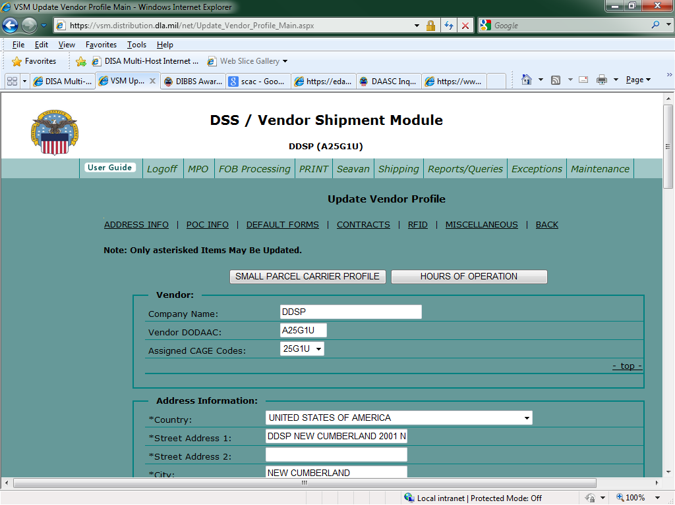

  - Offer Number for a single shipment = Vendor DODAAC + “SCN” + 01234567

    - Ex. A25G1USCN01234567

  - Offer Number for a Master Bill = Vendor DODAAC + “MBN” + 00001234

    - Ex. A25G1UMBN00001234

  - The location of the SCN & MBN on the CBL is addressed on the following pages.

- To know what carrier is picking up the freight, take the VIA Standard Carrier Alpha Code (SCAC) from the CBL shown on the following slides, and look it up on the SCAC list at the end of this document.

- When contacting DLA Distribution for assistance in answering your questions, please provide your CBL number, Shipment Control Number (SCN) or Master Bill Number.

- The following pages contain screen prints, which illustrate where this information is located on the CBL.

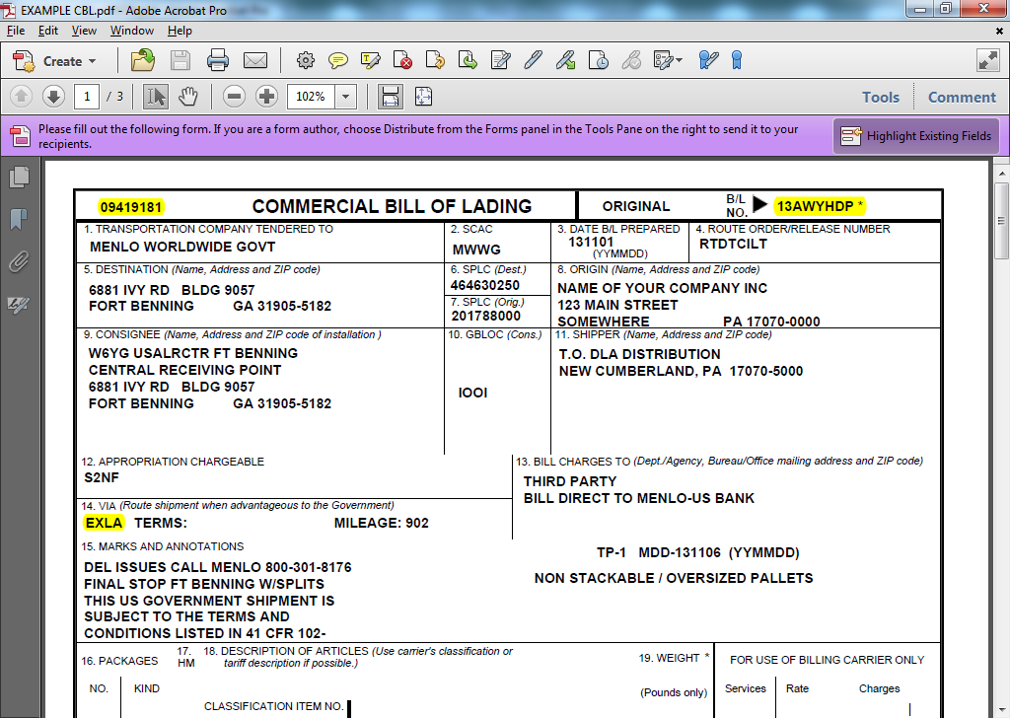

- The VIA SCAC is displayed in box 14. This is the Carrier that has been awarded to pick up the shipment.
- The Shipment Control Number is displayed on the upper left hand side of the CBL and is the last (third) part of the offer number.
- Commercial Bill of Lading (CBL) number

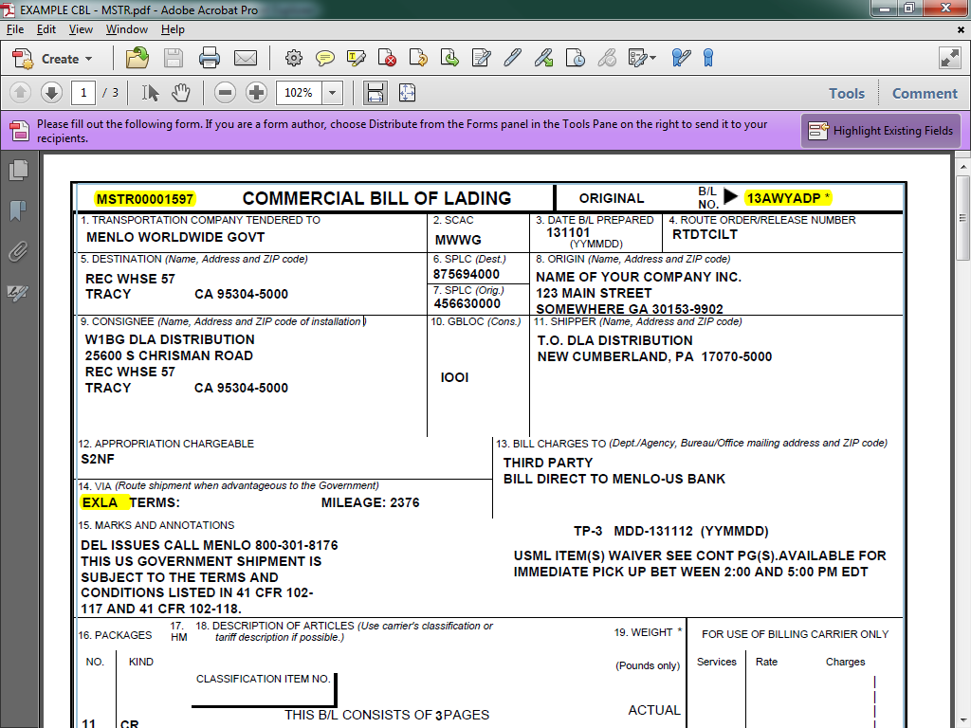

- When shipments are combined onto one CBL, a Master Bill Number will display in place of the SCN at the top of the first page.

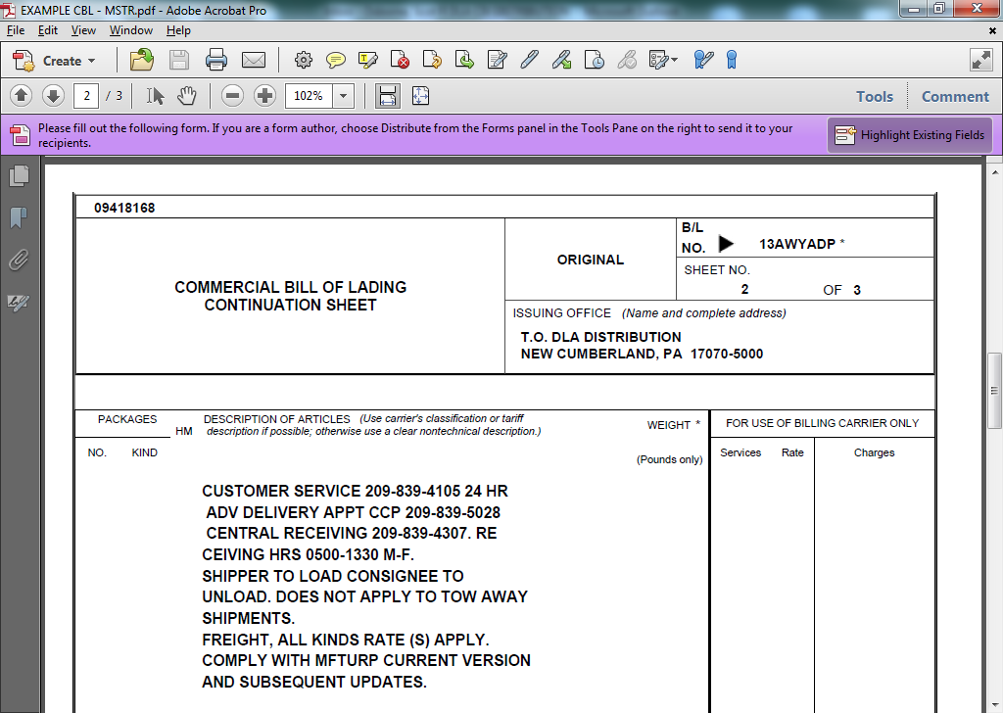

- Driver instructions
- SCN - The Master Bill is displayed on page 1 and the SCN is displayed at the top of the following pages.
- CBL – Carries over on the top of each page.

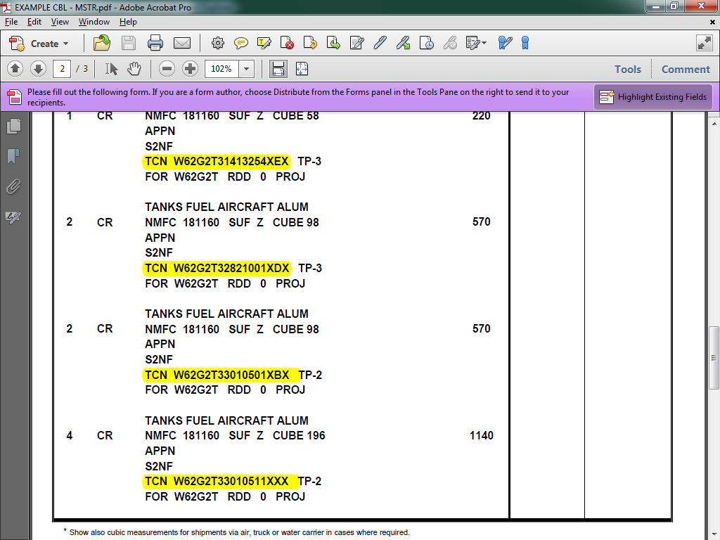

The Transportation Control Number (TCN) is listed on page 2 and subsequent continuation pages. These are the TCNs that were consolidated onto this shipment under one Master Bill and can be used to search by in VSM.

CARRIER NAMES AND SCACs

SCAC | Carrier Name
AATJ | ACCESS AMERICA TRANSPORT
ACEH | ACE DORAN HAULING & RIGGING CO.
AHHA | ART HEAVY HAUL, INC.
AIPA | AMERICAN ROAD LINE, ARL INC.
ALKS | AUTONOMIC LOGISTICS
AMMF | ADMIRAL MERCHANTS MOTOR FREIGHT
ANAR | A&A TRANS-LAWRENCE
APEH | FREIGHT HANDLERS, INC. D/B/A APEX LOGISTICS GROUP
AQGC | ATLANTIC LOGISTICS INC.
AQLA | ALABAMA CARRIERS, INC.
AQNL | ALTERNATIVE LOGISTICS, LLC
ARNT | AMERICAN TRANSPORTATION
ASSM | ATS SPECIALIZED INC.
ATEQ | ACME TRUCK LINE, INC.
ATLN | ADD TRAN LOGISTICS
ATQW | AMERICAN TRANSPORT INC
AVXG | ADVANCED TRANSPORT, LLC
BAGS | BAGGETT SERVICES
BAME | BAM TRANSPORTATION, INC.
BFCO | B.E. COURIER SERVICE INC.
BFSJ | BM2 FREIGHT SERVICES, INC.
BGME | BENNETT MOTOR EXPRESS, LLC
BHEQ | BULLDOG HIWAY EXPRESS
BHRI | BUCHANAN HAULING & RIGGING, INC.
BWCE | BEST WAY CARGO/TRANSPORT
BXPE | BOLT EXPRESS, LLC
CALJ | CAL ARK INTERNATIONAL, INC.
CAOG | CARROLL TRUCKING INC.
CAST | CASTELL TRUCKING CORP. (C.T.C.)
CERE | CERES TRANSPORT
CFSN | CFS LOGISTICS, INC.
CHDI | CHEYENNE DISTRIBUTION INC.
CKGV | CASTELL TRUCKING GROUP LLC
CKLG | CHEROKEE LOGISTICS, INC.
CLGE | CELADON TRUCKING SERVICES
CLLQ | COYOTE LOGISTICS
CNWY | CON-WAY FREIGHT
CNYI | CANARY INC
COOG | CORTRANS LOGISTICS, LLC
CRDT | CARDINAL TRANSPORT, INC.
CRLC | CRST LOGISTICS, INC.
CRQC | DANIEL W. CARR, JR. DBA CARR TRUCKING COMPANY
CRTD | P. CARTER TRUCKING, INC.
CSTV | C & S TRUCKING & SALVAGE, INC.
CTII | CENTRAL TRANSPORT
CTRQ | CON-WAY TRUCKLOAD INC
CTWR | C2 FREIGHT RESOURCES, INC.
CVGT | CAVALRY LOGISTICS, LLC
CVQC | C. L. SERVICES, INC.
CWBG | CON-WAY MULTIMODAL INC
CWBL | COWBOY USA LLC
CXTB | COX TRANSPORTATION SERVICES, INC.
CXWW | INTERSTATE DISTR/CARGO EXPRESS, INC.
DATK | DAVIS EXPRESS INC.
DDJG | DOUBLE D TRUCKING
DIAT | DIAMOND TRANSPORTATION
DICE | DIAMOND LOGISTICS, INC.
DKQL | DRAKE LOGISTICS, LLC
DLMS | GREATWIDE - DALLAS & MAVIS
DTJF | D.T.S. FLATBED SERVICES
EARL | EASTERN EXPRESS, INC.
EFSD | ESTES FORWARDING WORLDWIDE LLC (SPECIALIZED)
EFWW | ESTES FORWARDING WORLDWIDE, LLC
ELLW | ESP LOGISTICS LLC
EPOI | EXPRESS-1/XPO
EQXC | THE EXPEDITING CO., INC.
ETCO | ETI/EXCLUSIVE TRANSPORTATION
EXLA | ESTES EXPRESS LINES
FDCC | FEDEX CUSTOM CRITICAL, INC.
FIKS | FTL LOGISTICS
GIDT | GID-GET IT DONE LLC D/B/A GID LOGISTICS
GRES | GRESHAM TRANSFER, INC.
GTTI | GO TO TRANSPORT
GVEI | GLOBAL SERVICE ASSOCIATE
GVTD | GREEN VALLEY TRANSPORTATION CORPORATION
HASK | EDWARD HINKLE DBA HINKLE AND SON TRUCKING
HGPS | HIGH PLAINS LOGISTICS CONSULTING, LLC
HHGI | HH&G, INC.
HJBT | J. B. HUNT TRANSPORT, INC.
HLOB | HAUL LOGISTICS
HNWT | H&W TRUCKING
HUBG | HUB GROUP, INC.
IGLN | PANTHER EXPEDITED/INTEGRES
IKXS | IKON TRANSPORTATION SERVICES, INC.
INTD | INTERSTATE DIST/CARGO EXPRESS
IWES | INTEGRATED WIND ENERGY SERVICES, LLC
JONS | JONES MOTOR CO., INC.
KBTP | K & B TRANSPORT, INC. OF GEORGIA
KSTK | K & S TRUCKING, LLC
KYTS | KEY TRANSPORT
LEAM | LANDSTAR EXPRESS AMERICA, INC.
LGGS | LEGION LOGISTICS
LGTC | LIVINGSTONE TRUCKING
LIGS | LANDSTAR LIGON
LLSK | LML LOGISTICS SOLUTIONS
LMJB | LMJ INTERNATIONAL LOGISTICS, LLC
LMJG | LMJ INTERNATIONAL LOGISTICS, LLC
LOJO | LOJO SPECIALIZED HAULING, LLC
LRGR | LANDSTAR RANGER
LRSL | LARS LOGISTICS/UNIFIED CONSULTANTS
LSST | LONE STAR TRANSPORTATION
LTPI | LOUISIANA TRANSPORT INC
MADL | MASON AND DIXON LINES
MCET | MERCER TRANSPORTATION CO., INC.
MDXD | MASON DIXON LOGISTICS
MDXW | MEDALLION TRANSPORT & LOGISTICS, LLC
MGIO | MAGNO INTERNATIONAL LP
MGPG | MEGACORP LOGISTICS, LLC
MGXB | MAGELLAN TRANSPORT LOGISTICS
MINB | MAGNO INTERNATIONAL LP
MLFJ | MALOON TRANSPORTATION
MLLV | R.E. MILLS
MYAF | MYSTIC TRANSPORTATION
NCOC | NORCO CORPORATION
NONT | NORTHERN NECK TRANSFER, INC.
NXLL | NEXT EXIT LOGISTICS, LLC
ODTI | OVERDRIVE TRANSPORTATION, INC.
PGTT | PGT TRUCKING
PIDS | PRIEFERT LOGISTICS, LP
PKDS | PACKARD TRANSPORT, INC.
PNAN | PRECISION HEAVY HAUL, INC.
PSTO | P&S TRANSPORTATION INC.
PTWT | PANTHER II TRANSPORTATION, INC.
PXEL | PRIMO EXPRESS LLC
QELA | QONTINUITY ENTERPRISES LLC
REBN | R. E. B. EXPRESS
REBQ | RED ARROW CONSULTING INC
RETR | RE TRANSPORTATION
RFTG | RELWOF FARMS TRUCKING, INC.
RHLT | ROCKHILL
RLPK | RADIANT LOGISTICS PARTNERS LLC
RLPL | RADIANT LOGISTICS PARTNERS LLC
RNWS | W.S. ROBINSON
ROEV | ROEHL TRANSPORT, INC.
RPTY | RP TRUCKING LLC
RTSB | RELIABLE TRANSPORTATION SOLUTIONS
RWCY | VALUE TRANSPORT dba RWC TRANSPORT
RYFS | RAYNOR FARM SERVICES INC.
RYPR | READY TRANSPORTATION INC
SAGQ | SOUTHERN AG CARRIERS, INC.
SAMM | SAMMONS TRANS
SLTW | SLT EXPRESS WAY, INC.
SLZC | SOURCE LOGISTICS LLC
SPCG | SPECIALIZED TRANSPORTATION, INC.
SWIB | SWI TRANSPORTATION, INC.
TAES | TEAM AIR EXPRESS, INC.
TAIF | TEAM AIR EXPRESS, INC.
TCAR | TRANS CARRIERS INC
TCZN | TNT CARTAGE
TENH | TENNESSEE STEEL HAULERS, INC.
TGNB | BUS DEV & BEYOND, INC. DBA TRANGISTICS
TJIQ | TJI LOGISTICS, INC.
TLSI | TRANSPORTATION & LOGISTICAL
TMQH | TOMCAT MILITARY LOGISTICS LLC
TNXF | TURNER TRANSPORT
TQYL | TOTAL QUALITY LOGISTICS
TRSQ | TERESI TRUCKING INC
TVFT | TRAVERSE FREIGHT INC.
UACL | UNIVERSAL AM-CAN
ULLQ | US LOGISTICS, LLC
UPGF | UPS GROUND FREIGHT, INC. DBA UPS FREIGHT
UVGS | UNIVERSAL LOGISTICS
VGJW | JERRY VIRGIL D/B/A/ J & W VIRGIL TRUCKING CO
VLLQ | VERDE LOGISTICS
VLOB | VETUS LOGISTICS
WRXE | WRIGHT EXPRESS SERVICE
WSHK | WOODEN SHOES TRUCKING INC.
WTEM | WILSON TRUCKING SERVICE INC.
XCTG | XCELERATED TRANSPORTATION GROUP LLC

